T-V6 vertical machining center
Technology Agreement

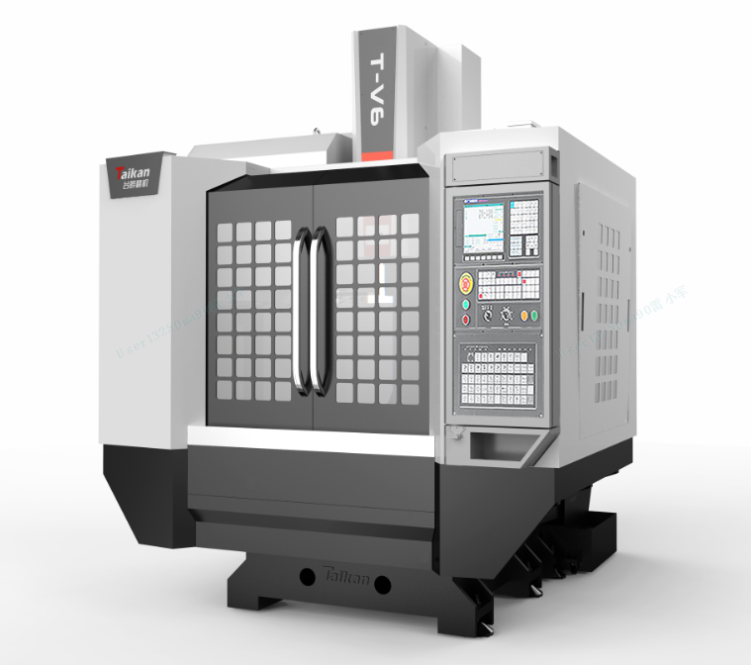
Party A（buyer）： | Represent：  date：
Party B（seller）： Shenzhen Genesis Machinery Co., Ltd. | Represent：  date：
（The pictures are for reference only）

Directory

1. Equipment technical description, parameters, and configuration 1
1.1. Equipment technical description 1
➢ The base structure 1
➢ The foundation parts 1
➢ The spindle 1
➢ Guide rails 1
➢ The lubrication system 2
➢ The tool magazine 2
➢ Chip removal 2
➢ CNC system 2
➢ Working conditions 2
1.2. Equipment Parameter and configuration 3
1.2.1. Basic Parameters 3
1.2.2. Standard configuration 5
1.2.3. Customer optional configuration 6
2. Core component brands 7
3. System main function table 8
4. Recommended oil and grease table 13
5. Routine maintenance and upkeep of machine tools 14
6. Quality assurance 14
7. Others 15

Equipment technical description, parameters, and configuration

Equipment technical description
T-V6 linear guide rail type vertical machining center, is a small-size machine tool. With a workpiece each clamping cycle, it is capable of performing automatically and continuously various machining operations such as milling, drilling, boring, expanding, reaming, countersinking, tapping, and other processes, The machine tool is suitable for processing various types of small and medium-sized batches of complex parts such as small-sized boxes, plates, disks, valves, shells, molds, etc. The machine tool adopts high-precision linear guide rails and screws with the better dynamic response, which achieves high-speed cutting and no crawling at low speed. It is widely used in precision parts, 5G products, hardware, auto parts, and medical equipment industries.
- The base structure: The base structure is digitally analyzed and specially designed with large-span six-point support, which improves the rigidity and vibration resistance of the machine tool to ensure good stability of the machining process;
- The foundation parts: The basic large parts are made of high-quality resin sand molding and high-strength cast iron materials to ensure high rigidity and stable accuracy of the machine tool.
- The spindle: The spindle adopts a high-speed spindle unit from Taikan. Spindle adopts a BT40-12000 r/min direct-connected head, equipped with an automatic constant temperature circulating oil cooling device, which makes the spindle temperature rise is small, thermal deformation is small, to maintain high machining accuracy.
- Guide rails: Three axis adopt ball linear guide rails, featuring high rigidity, low friction and high load capacity.
- The Z-axis adopts a brake-type servo motor with a counterweight-free design to improve the Z-axis drive performance and achieve the best surface accuracy when performing 3D processing.
- The full-stroke moving accuracy is compensated by laser correction to ensure the accuracy and calibration result of the machine.
- The lubrication system: Equipped with automatic lubrication system to ensure good lubrication of all moving parts of the machine tool.
- The tool magazine: The tool magazine adopts 24T arm-type tool magazine from Taikan, which has reliable quality and stable performance.
- Chip removal: The large inclined chip removal angle of the machine makes it possible to remove chips quickly and accelerates the return speed of cutting fluid.
- CNC system: The machine is equipped with the high-performance FANUC 0i-MF PULS (5) CNC system, which guarantees the stability of the machine control, as well as the CNC machining functions and auxiliary functions requested by the user.

Working conditions
- Three-phase AC power supply: 380V±5%; 50Hz±1Hz; main power cord, ground wire 6mm² or larger.
- Ambient temperature: need to keep the ambient temperature 17 ~ 25 ℃, If the precision requirements of processing parts are not high, can be relaxed to 5 ~ 40 ℃. Storage or transport temperature -20～60℃
- Room temperature change: The ambient temperature changes within ±2°C within 24 hours.
- Relative humidity: Within 75% (no condensation);
- Altitude: Below 1000m;
- Vibration: Below 0.2G；
- Foundation requirements: bearing capacity above 50KN/m²；
- Keep away from light sources, vibration sources, and heat sources, and away from high-frequency generators, dischargers, welding machines, etc. to avoid electrical interference that may cause machine tool NC system malfunctions.

Equipment Parameter and configuration

Basic Parameters
Name |  |  | Unite | Parameter | Remark
Stroke range | Worktable stroke(X-axis) |  | mm | 600
Stroke range | Saddle stroke(Y-axis) |  | mm | 390
Stroke range | Spindle box stroke(Z-axis) |  | mm | 450
Stroke range | The distance from the spindle end face to the worktable |  | mm | 190～640
Worktable | Worktable size |  | mm | 700*400
Worktable | Worktable load |  | Kg | 250
Worktable | T-shaped slot (number of slots-slot width*spacing) |  | mm | 3-18*125
Spindle | Motor power (rated/short time S3/S6 25%) |  | kw | 7.5/11
Spindle | Motor torque (rated/short time S3/S6 25%) |  | N.m | 35.8/70
Spindle | rotation speed range |  | r/min | 20～12000  (direct-connected）
Spindle | Spindle diameter |  |  | φ120
Spindle | Handle specifications |  |  | BT40
Spindle | blind rivet specification |  |  | P40T-I（MAS403）
Guide rail | X-axis |  |  | 2-25 ball
Guide rail | Y-axis |  |  | 2-30 ball
Guide rail | Z-axis |  |  | 2-35 ball
Drive | Screw X/Y/Z |  | mm | 25/25/32
Drive | Motor power X/Y/Z |  | kw | 1.8/1.8/3.0
Speed | Cutting feed speed range |  | mm/min | 1-10000
Speed | Fast-moving speed of X/Y/Z-axis |  | m/min | 48/48/48
Machine tool accuracy | Positioning accuracy (X/Y/Z) |  | mm | 0.006 | GB/T18400.4  （Full stroke）
Machine tool accuracy | Repeated positioning accuracy（X/Y/Z） |  | mm | 0.004 | GB/T18400.4  （Full stroke）
Tool magazine（optional） | Tool magazine capacity |  | T | 24
Tool magazine（optional） | Tool weight |  | kg | 7
Tool magazine（optional） | Tool length |  | mm | 250
Tool magazine（optional） | Maximum diameter (full tool /adjacent empty tool) |  | mm | Φ75/Φ150
Other | CNC system |  |  | FANUC 0i-MF Plus(5)
Other | Gas source | flow | L/min | ≥280（ANR)
Other | Gas source | air pressure | MPa | 0.6∼0.8
Other | Equipment capacity |  | KVA | 15
Other | Cooling box volume |  | L | 145
Other | Machine tool appearance dimensions (length*width*height) |  | mm | 2100*2580*2670 | Corresponds to X*Y*Z axis
Other | Main unit weight (approx.) |  | Kg | 3500
#: The appearance dimensions of the machine tool may change due to configuration without further notice.

Standard configuration
No | Name | Amount | Remark
1 | FANUC 0i-MF Plus(5) CNC system | 1
2 | Operation panel | 1
3 | Pneumatic system | 1
4 | air gun | 1
5 | Automatic lubrication system | 1
6 | Spindle oil cooling system | 1
7 | Workpiece cooling system | 1
8 | Three-axis built-in encoder feedback system | 3
9 | Three-axis protective cover | 3
10 | Full protection | 1
11 | Three-color light | 1
12 | Lighting devices | 1
13 | Basic installation kit | 1
14 | Randomized sets of standard technical documents | 1

Customer optional configuration
No | Name and specification | Selection | Remark
1 |  | √
2
3
Note: If you select this configuration, mark √ in the corresponding item box

Core component brands
Core component brands and specification
No | Component name | Brands | Remark
1 | Controller systems | FANUC 0i-MF Plus(5) system
2 | Spindle unit | Taikan
3 | Three-axis bearings | Japan NSK/GermanyFAG
4 | Three-axis screw | Taiwan PMI/Hiwin
5 | Ball linear guide rails | Taiwan PMI/Hiwin
6 | 24T arm-type tool magazine | Taikan
7 | Oil cooler | Tongfei
8 | Electrical components | French Schneider
9 | Relay | Japan Omron
10 | Automatic lubricator | Chen Ying
11 | Server Driver | Japan FANUC
12 | pneumatic components | Japan SMC
Note: When supply is insufficient, other brands of products will be used instead, but the quality and grade will not be lower than the listed configurations.

System main function table
（Some functions need to be combined with the configuration of the host to be realized）
No | Function | clarification
1 | Number of control paths | 1
2 | Maximum total number of control axes (servo axis + spindle) | 6
2 | Maximum number of servo axes | 5
2 | Maximum number of spindles | 1
3 | Control the number of axes simultaneously | 4
4 | Display unit | 10.4＂LCD
5 | Servo HRV control | High-speed, high-precision servo control
6 | Program capacity | 512K（1280m）
7 | I/O Link i | 1024/1024
8 | Automatic data backup | Backup of machine data
9 | Memory Card Edit/Run | DNC online processing
10 | Program folder management | Functions for using macro programs and machining programs
11 | FSSB High-speed rigid tapping | Reduced rigid tapping time and errors
12 | Intelligent backlash compensation | Backlash compensation
13 | PMC axis control | Used when the tool magazine is a servo tool magazine
14 | Data transfer via embedded Ethernet | Data transfer function via Ethernet
15 | USB transfer program to CF card | Data transfer function
16 | Servo Guide Mate | Servo optimization
17 | Spindle Intelligent load meter | Monitoring spindle current and other status
18 | AI contour control | Pre-reading of program segments within 40 segments (others are not optional)
19 | Smooth tolerance control | Determine the appropriate machining speed by commanding allowable tolerances
20 | Intelligent overlap | Achieving reduction of cycle times for machining parts
21 | Spindle HRV control | High-speed, high-precision servo control
22 | Imperial/Metric Conversion | Conversion of machine tool units
23 | HRV2 control | High-speed, high-precision servo control
24 | HRV3 control | High-speed, high-precision servo control
25 | FANUC SERVO GUIDE | Servo adjustment for high-speed, high-precision processing in a short time
26 | Flexible feed gear | Arbitrary DMR
27 | Minimum setting unit（0.0001mm、0.0001deg、0.00001 inch） | The smallest unit of the system
28 | Mirror | Each axis
29 | Rigid tapping retraction | Rigid tapping retraction
30 | Buffer register | The system can cache data
31 | Positioning | Spindle positioning function for tapping and tool changing
32 | Linear interpolation | Linear machining function
33 | Circular arc interpolation | Circular arc processing function
34 | Spiral interpolation | Spiral processing function
35 | Thread cutting, synchronous feed | Thread cutting, synchronous feed
36 | Flip of the rotary axis | Flip of the rotary axis
37 | Arbitrary Angle Chamfer/Corner R | Arbitrary Angle Chamfer/Corner R
38 | Fixed cycle for drilling | Fixed cycle for drilling
39 | No block reference point setting | No block reference point setting
40 | Automatic cornering magnification | Automatic corner processing ratio control
41 | Scaling | Scaling
42 | Plane selection | G17 G18 G19
43 | Programmable mirror | Programmable mirroring of each axis
44 | Single program segment | Single-segment of the program can be executed
45 | Program restarts | After the program is temporarily interrupted, it can be restarted
46 | Tool diameter, tool nose radius compensation | Tool parameter compensation
47 | Tool life management | Tool life management
48 | Tool life management extension | Tool life management extension
49 | Backlash compensation | Machine tool axis backlash compensation function
50 | Position tracking | Position tracking
51 | Abnormal load detection | Abnormal load detection for each axis
52 | Position switch | Program protection function
53 | Backstage Editing | Program editing can be performed in edit mode
54 | National language display function | System operation interface language display function 10 kinds
55 | Self-diagnosis function | Can monitor machine tool status
56 | Help function | Please refer to System Alarm
57 | Nano interpolation | Nano interpolation
58 | Workpiece coordinate system | G52~G59
59 | Absolute/Incremental Instructions | Can be mixed in the same program section
60 | Fault diagnosis | Can find current machine tool fault conditions
61 | Clear screen | Manual or automatic clearing of the screen
62 | Power consumption monitoring | Can check the power consumption of machine tools

Recommended oil and grease table
Used parts | Name | Capacity | Grades | Manufacturer recommendation | Remark
Hydraulic station (optional) | Hydraulic oil | 40L | 46# | Shell Tellus 46  或长城HF-2 46 | Replace it after 3 months of initial use; replace it every 6 months thereafter
Oil cooler | Cooling oil | 40L | 32# | Shell Tonna T32或Great Wall HG32 | Replace it after 3 months of initial use; replace it every 6 months thereafter
Lubrication pump | Guide rail oil | 4L | 32#  （winter）  68#  （summer） |  | Fill when the oil level is below the minimum level line
Requirements: For the cutting fluid in use, please follow the manufacturer's instructions to properly manage the pH, the mixing degree of the original solution and dilution water, the salt concentration of the dilution water, and the frequency of cutting fluid replacement. If you use cutting fluids and guide oils other than those recommended, pay full attention to the usage methods and conditions. Depending on the interaction of the coolant and guide oil, etc., it may sometimes cause poor lubrication of the screw and guide rails and the generation of scum, which will reduce their durability. Therefore, please check with the manufacturer carefully before use.

Routine maintenance and upkeep of machine tools
Please follow the "Operating Instructions" for daily, weekly, monthly, quarterly and annual inspections and maintenance; the disassembled parts must be reinstalled after completion of maintenance.

Quality assurance
- The quality guarantee period is 12 months from the date of final acceptance.
- During the warranty period, if the buyer uses the equipment or machine tool under normal conditions in accordance with the instruction manual, the seller will be responsible for any damage caused by defects in factory design or manufacturing. During the above warranty period, if there is a problem with the equipment, the seller will make correction suggestions to the buyer; if the buyer still cannot solve the problem according to the seller's instructions and system description, the seller shall dispatch a maintenance engineer free of charge within 2 working days after receiving the buyer's notice. Arrive at the buyer's factory.
- During the warranty period, the seller shall provide the buyer with timely maintenance services and necessary spare parts free of charge. It is verified that the failure loss caused by the buyer's improper operation, unreasonable cutting parameter selection or self-disassembly and modification, and other non-manufacturing quality reasons, as well as the damage to the appearance or interior of the machine tool caused by excessive storage time, are not covered by the above warranty, and the buyer must pay for relevant maintenance cost.
- After the warranty period, the seller will maintain the machine tool for life and provide free online services and technical guidance. Provide timely supply of spare parts to buyers at favorable prices. If it is necessary to send someone to the site for repairs, the corresponding fees will be charged according to the seller's standards.

Others
1. Matters not covered in this agreement shall be resolved through negotiation between the two parties.
2. This agreement is an attachment to the contract and will take effect simultaneously with the contract after it is signed by Party A and Party B.
3. This agreement is made in duplicate, with Party A and Party B each holding one copy.

